**Docker Assignment 4**

**You have been asked to:**

A. Create a Dockerfile with the following specs:

● Ubuntu container

● Apache2 installed

● Apache2 should automatically run once the container starts

B. Submit the Dockerfile, for assignment completion

--------------------------------------------------------------------------------

A. Create a Dockerfile with the following specs:

● Ubuntu container

● Apache2 installed

● Apache2 should automatically run once the container starts

**Problem A Solution:**

**Step 1: Create** a **Dockerfile** using the **below-given command: vim Dockerfile.**

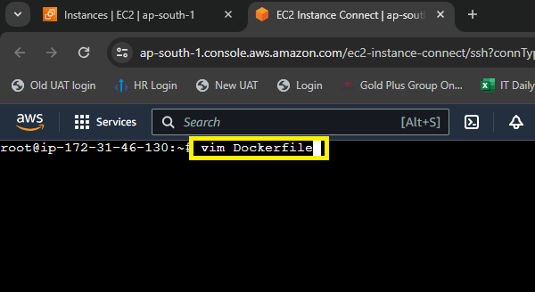

**Step 2: Write** the **following commands** in the **Dockerfile** to **create** the **container** & **automatically starts** the **Apache2.**

FROM ubuntu

RUN apt update

RUN apt install apache2 –y

ENTRYPOINT apachectl –D FOREGROUND

***Do :wq! To save & quit the file. Your Dockerfile will be saved with these instructions.***

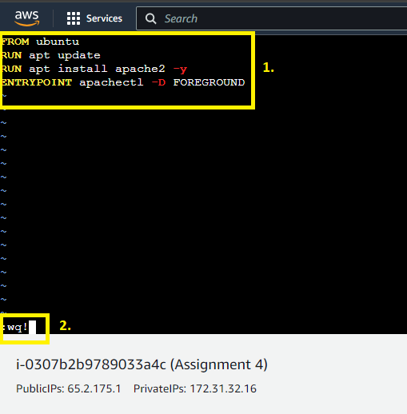

**Step 3: Now, we** will **create** a **new image using** this **Docker file** through this **command: “docker build –t assignment4 .” We use .** because **Dockerfile** is **present** in the **same directory.**

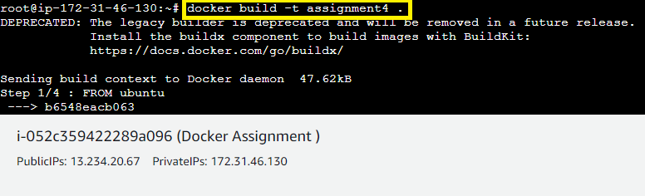

**Step 4: Now, when we run** the **“docker images” command. It** will **show** the **created image** asthe **“assignment4”.**

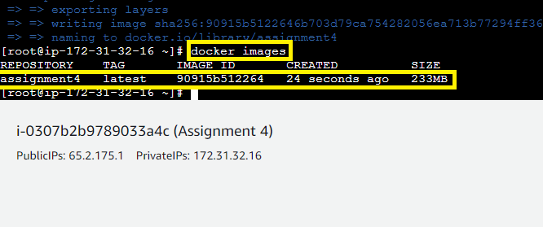

**Step 5: Now, we** will **create** a **container using** this **command: “docker container run –itd –p 80:80 --name testcont assignment4”.**

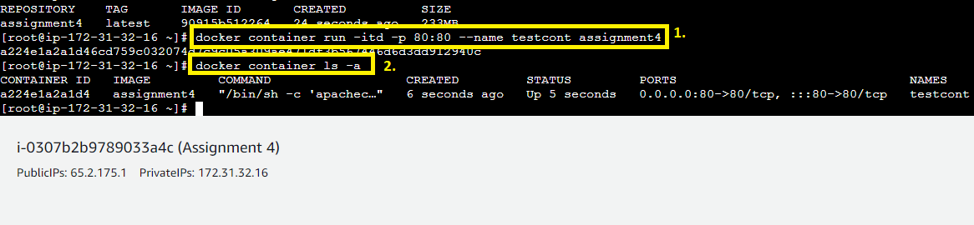

**Step 6: Go** to **the “Instance”. Select** the **“instance”** & **click** onthe **“open address”** inthe **“Public IPv4 address”.**

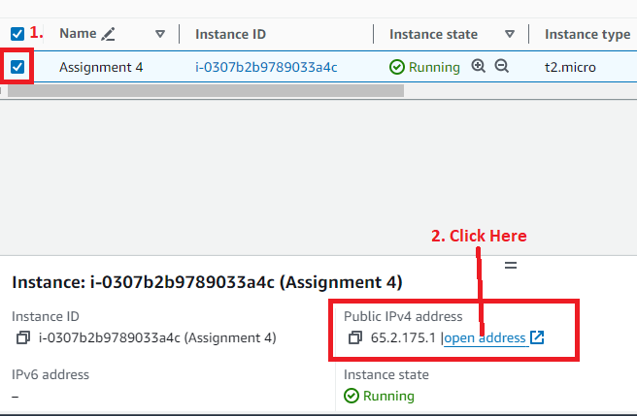

**Step 7: Put :80 behind** the **IP Address** & **you will get** the **by default Apache2 Web Page.**

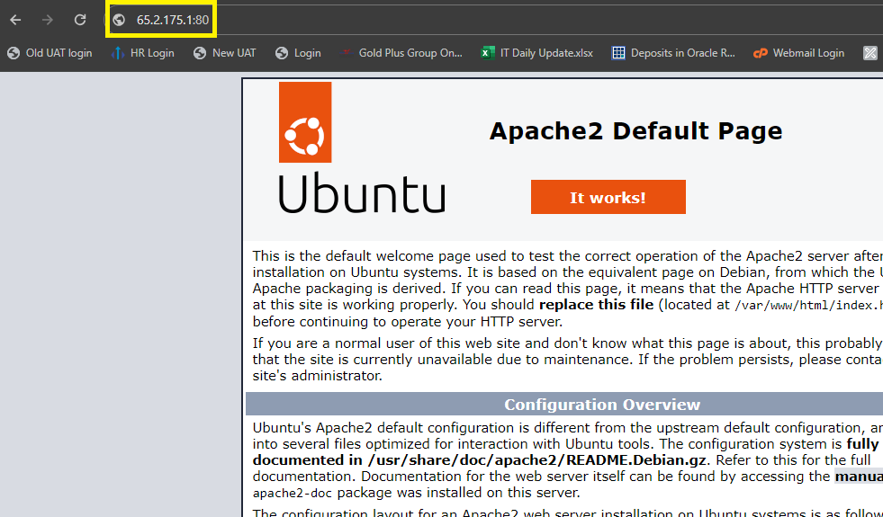

**B. Submit the dockerfile, for assignment completion**

**Dockerfile Content**

FROM ubuntu

RUN apt update

RUN apt install apache2 –y

ENTRYPOINT apachectl –D FOREGROUND

***Do :wq! To save and quit the file. Your Dockerfile will be save with these instructions.***

